Point 1: x = 1.9895, y=1.199745

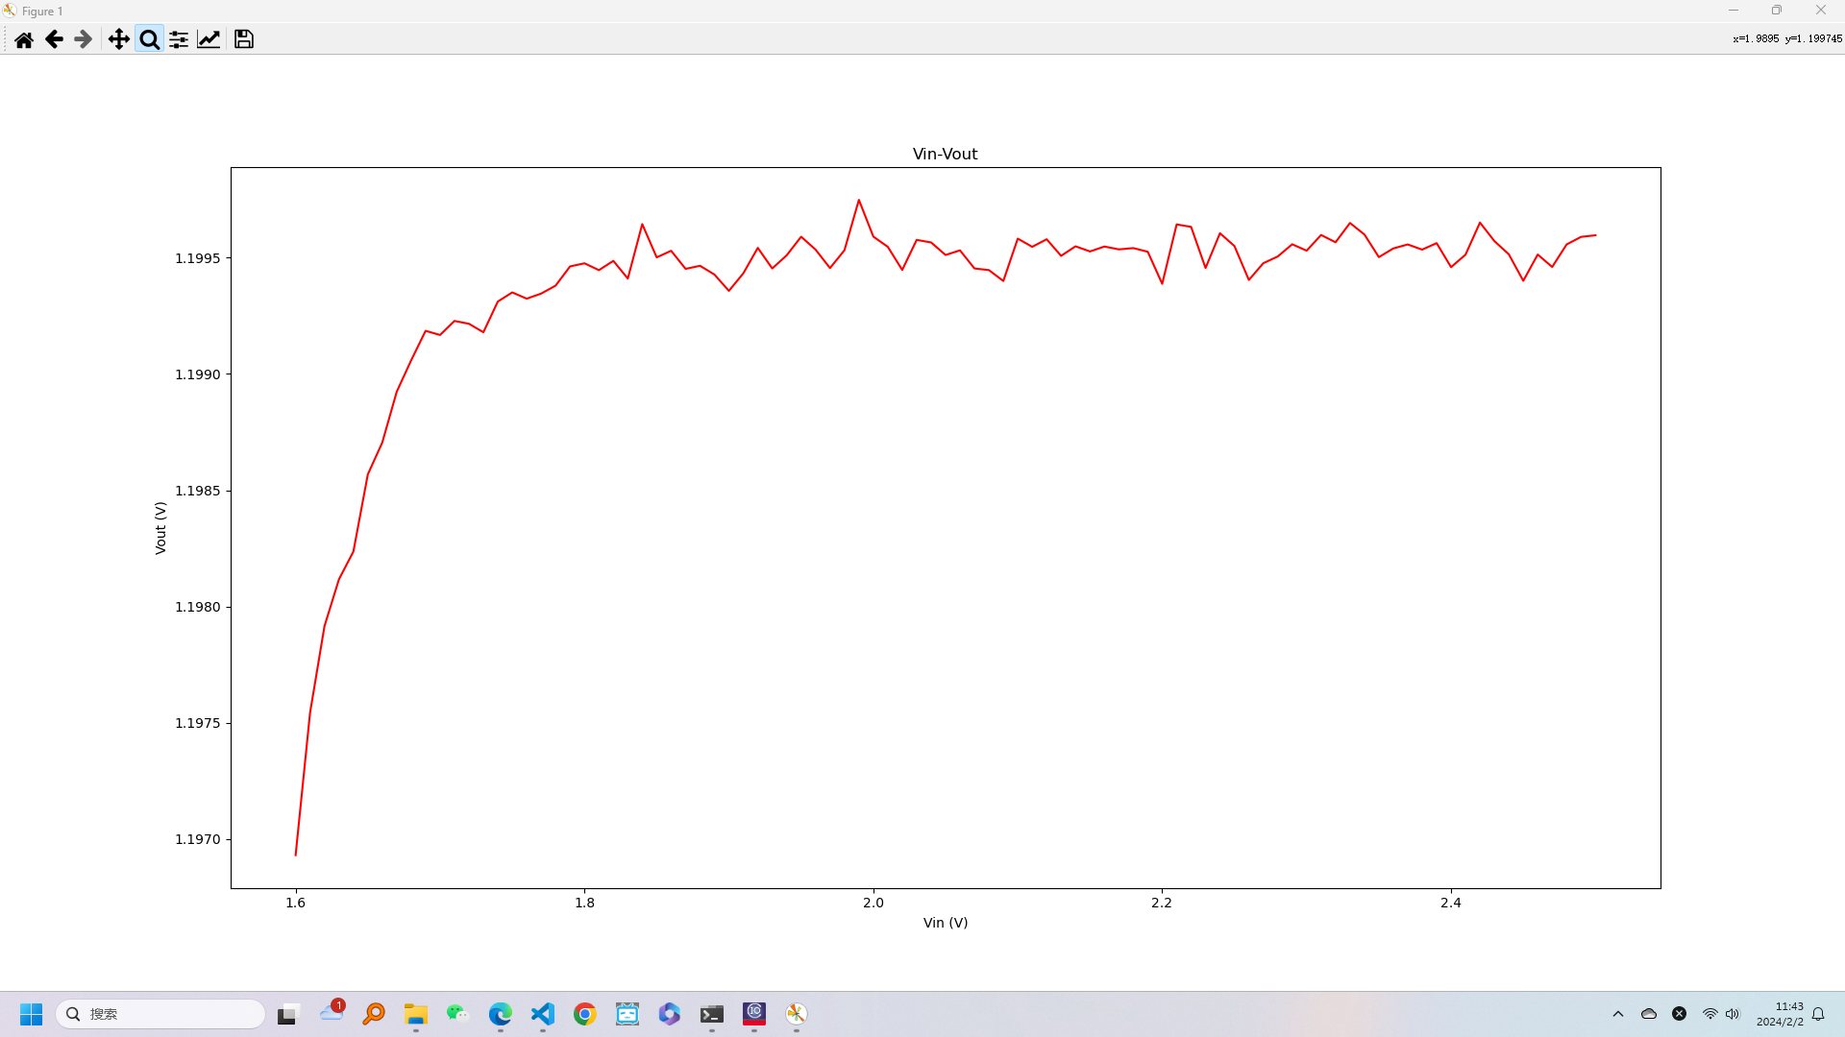

Point 2: x=1.6009, y=1.196929

